**1.Transport layer protocol header analysis using Wireshark-DNS**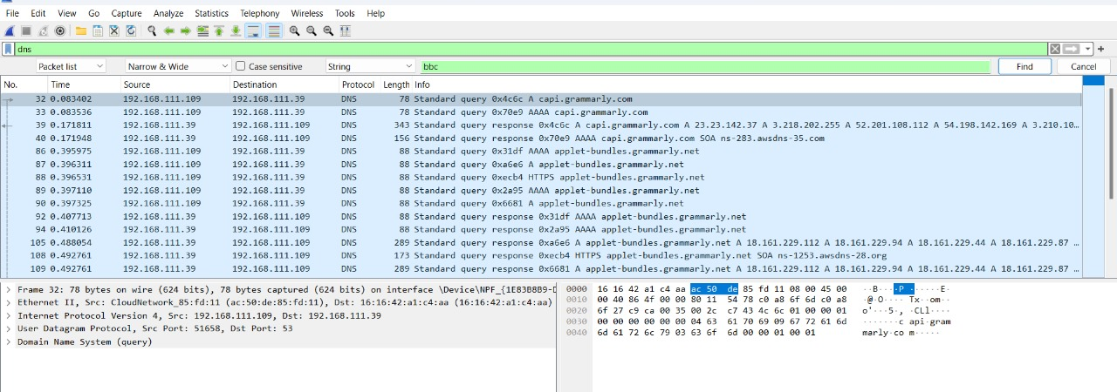

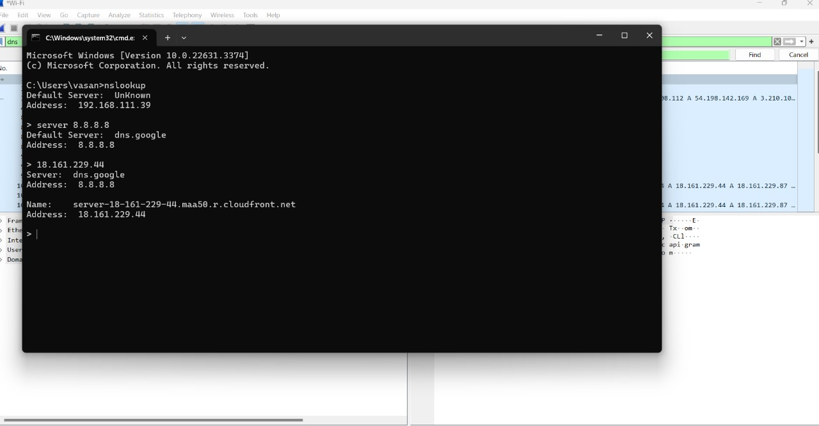

**2.Transport Layer Protocol Header analysis using Wireshark-TCP**

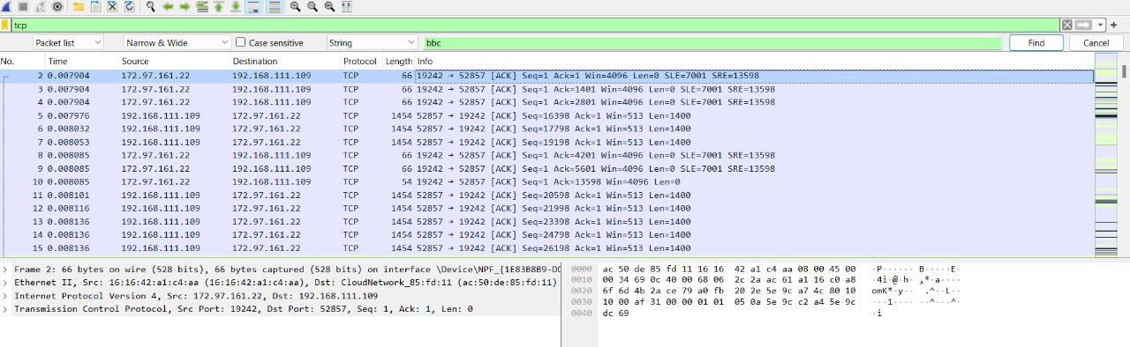

**3.Network layer protocol header analysis using Wireshark-ICMP**

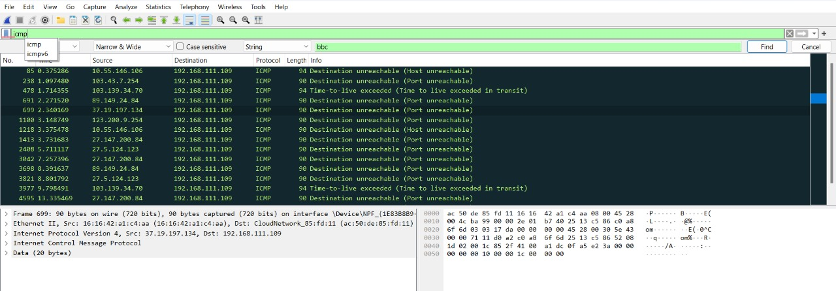

**4.Transport layer protocol header analysis using Wireshark-UDP**

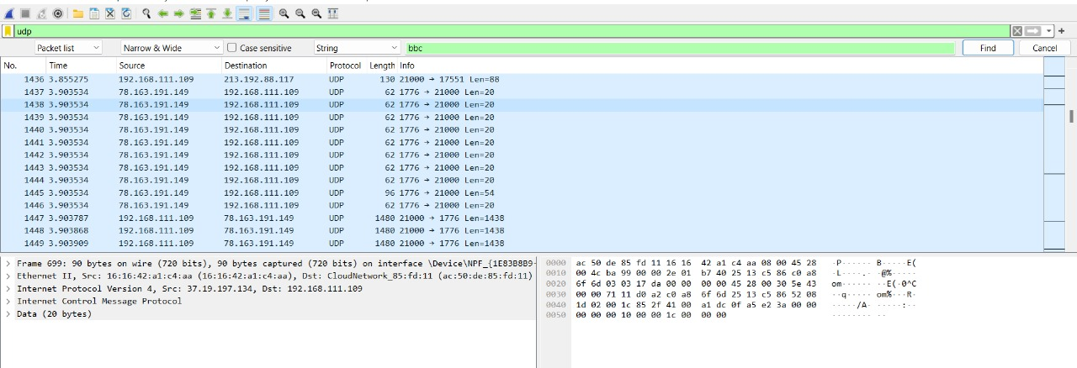

**5.Network layer protocol header analysis using Wireshark-ARP**

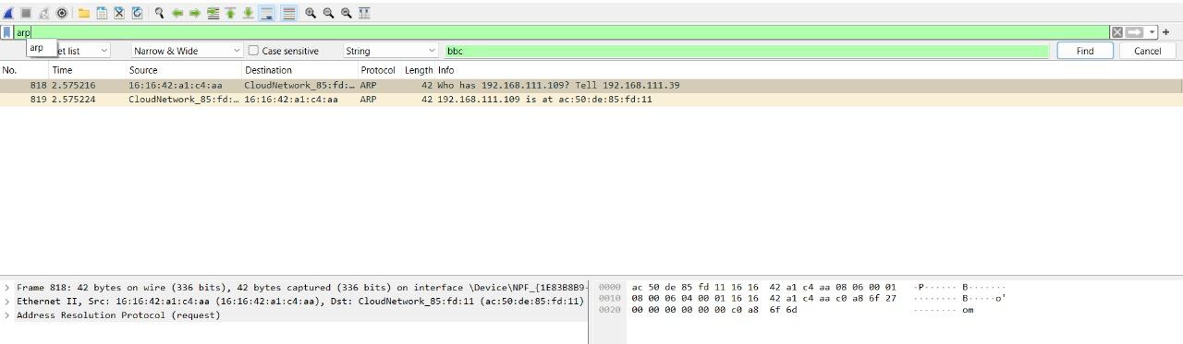

**6.Network Layer Protocol header analysis using Wireshark-HTTP**

